MTH401-Differential Equations
Fall 2010 Mid Paper 14, Dec 2010
BY
*~*SHINING STAR*~*($$)

- For a differential equation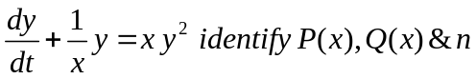

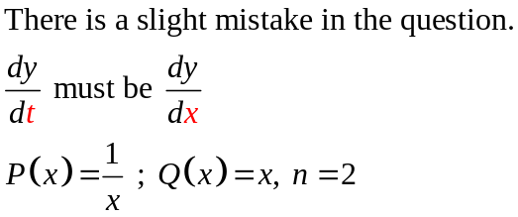
- For an Ist order linear differential equation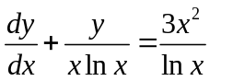,if the integrating factor 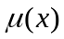 is 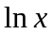 then the solution of differential equation is

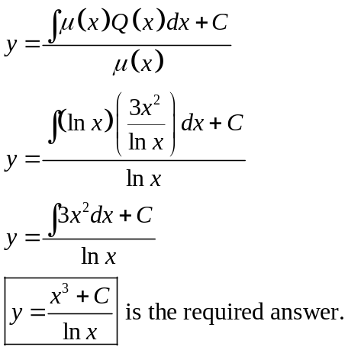

- Find the annihilator operator of the function and give reason for operator?
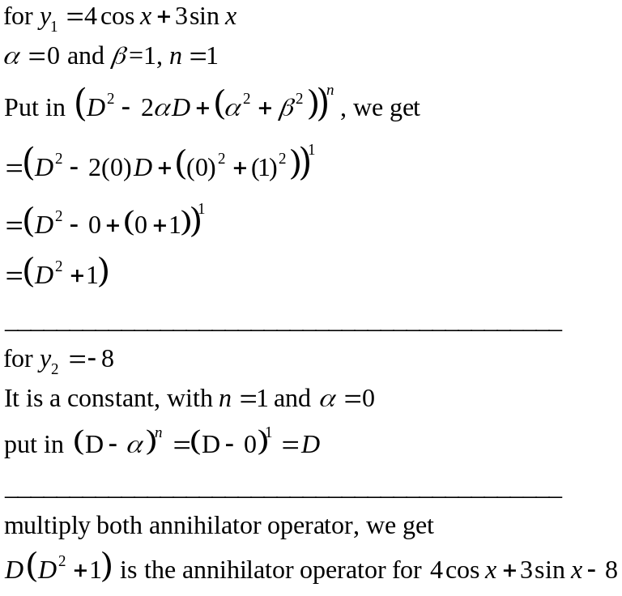
The above annihilator operator annihilates the given function. i.e. if we apply above annihilator operator to the given function, result will come out to be zero.

- What is an auxiliary equation of a homogeneous Differential equation? Also give its two examples?

- Find the auxiliary equation of the differential equation 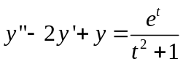?

Answer.
When we solve non-homogeneous/homogeneous differential equations with constant coefficients or variable coefficients, we start by assuming that a given particular function (which can never be zero) is a solution of given differential equation. That function includes some particular variable which in our case is m, What we do is we take derivatives of that function, put in given differential equation and then take that factor out that particular function. Doing so, results in an equation, which includes an algebraic equation. This algebraic equation can be equal to zero. It will have roots, either complex or real roots. This equation is named as Auxiliary Equation. However, characteristic equation is also another name for this equation.
Some examples of the auxiliary equation could be

For y’’+y = 0, auxiliary equation is m²+1=0
For y’’+2y’+y=0, auxiliary equation is m²+2m+1=0

Find the auxiliary equation of the differential equation ?

Auxiliary equation is m²-2m+1=0

- What isWronskian of the function 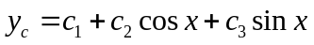
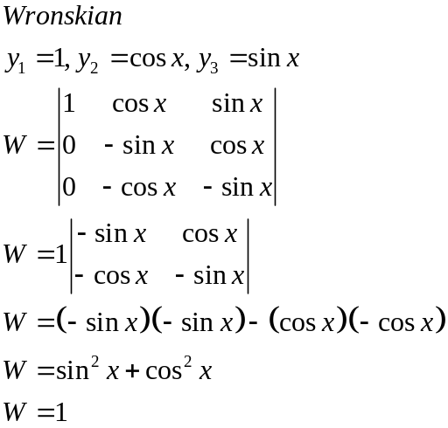

- Two solutions of 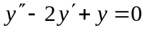 are e^{x} and x e^{x}. Is the general solution is
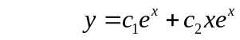?

Yes, auxiliary equation is m^2-2m+1=0, which is (m-1)^2 = 0, m=1, 1
Therefore, general solution is indeed

- Write solution 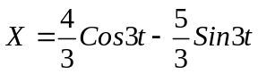in the form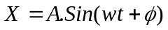.
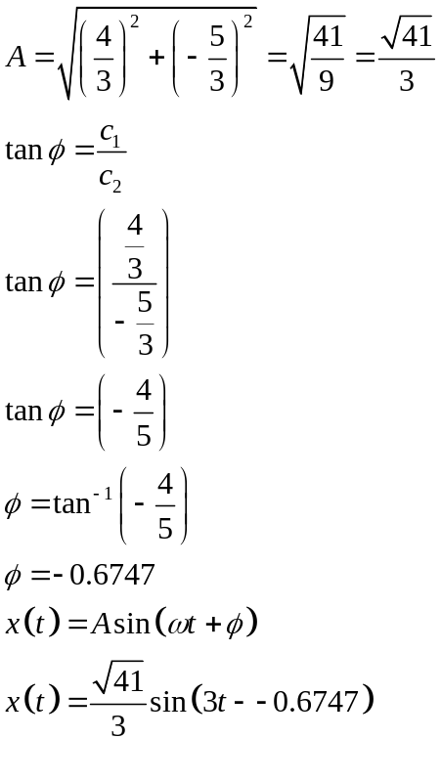
- What is the auxiliary equation of y=cos2x
